Request for quotation for developing a smart phone application

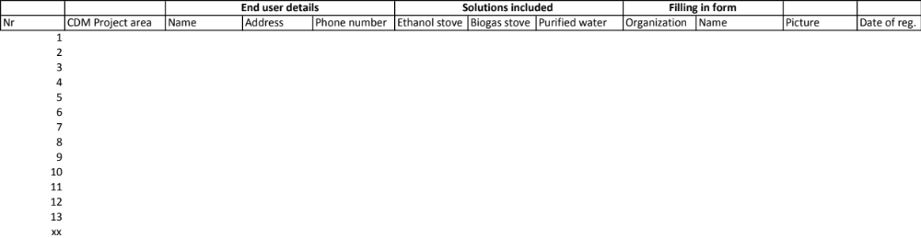

The date from smart phone application should upload data directly into a database. There might be more than 100 000 households registered by this application. But only a few hundred people will use the application (the users of the application will register end users. Each user of the application will register several 100 end users.

We need a quote for a company that can develop this smart phone app. The application should work on both Apple and Android phones.

Any quotation for such a job can be given to
Havard Norstebo, General Manager, Green Development AS
Email: havard.norstebo@gmail.com

